**UrbanShadows (SQL Case Study)**

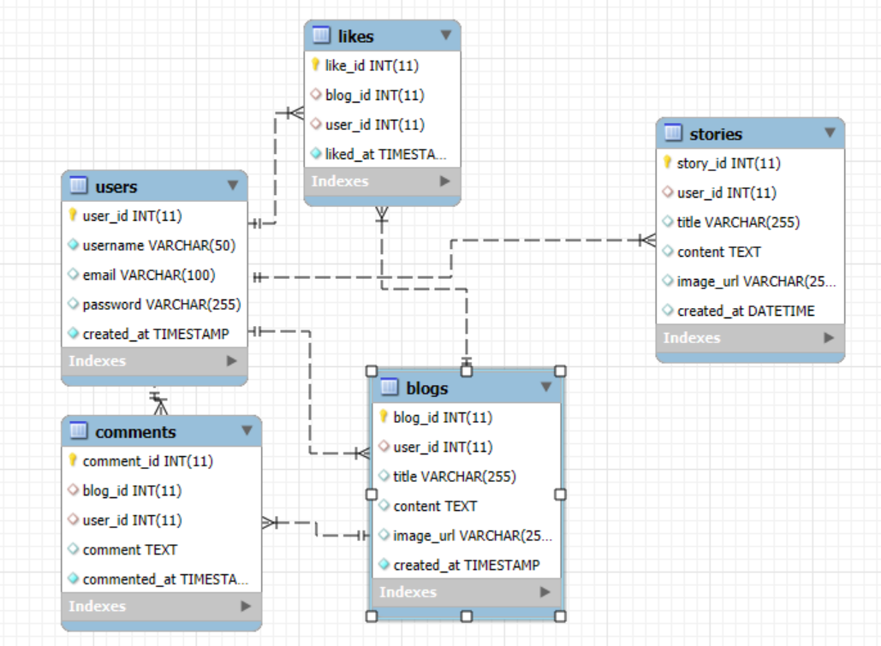

**Create tables for the following table names**

|  |  |
| --- | --- |
| **-- 1. Users table**  CREATE TABLE users (  user_id INT PRIMARY KEY AUTO_INCREMENT,  username VARCHAR(50) NOT NULL UNIQUE,  email VARCHAR(100),  password VARCHAR(255),  created_at TIMESTAMP DEFAULT CURRENT_TIMESTAMP  ); | **-- 2. Blogs table**  CREATE TABLE blogs (  blog_id INT PRIMARY KEY AUTO_INCREMENT,  user_id INT,  title VARCHAR(255),  content TEXT,  image_url VARCHAR(255),  created_at TIMESTAMP DEFAULT CURRENT_TIMESTAMP,  FOREIGN KEY (user_id) REFERENCES users(user_id)  ); |
| **-- 3. Likes table**  CREATE TABLE likes (  like_id INT PRIMARY KEY AUTO_INCREMENT,  blog_id INT,  user_id INT,  liked_at TIMESTAMP DEFAULT CURRENT_TIMESTAMP,  FOREIGN KEY (blog_id) REFERENCES blogs(blog_id),  FOREIGN KEY (user_id) REFERENCES users(user_id)  ); | **-- 4. Comments table**  CREATE TABLE comments (  comment_id INT PRIMARY KEY AUTO_INCREMENT,  blog_id INT,  user_id INT,  comment TEXT,  commented_at TIMESTAMP DEFAULT CURRENT_TIMESTAMP,  FOREIGN KEY (blog_id) REFERENCES blogs(blog_id),  FOREIGN KEY (user_id) REFERENCES users(user_id)  ); |
| **-- 5. Stories table**  CREATE TABLE stories (  story_id INT PRIMARY KEY AUTO_INCREMENT,  user_id INT,  title VARCHAR(255),  content TEXT,  image_url VARCHAR(255),  created_at DATETIME DEFAULT CURRENT_TIMESTAMP,  FOREIGN KEY (user_id) REFERENCES users(user_id)  ); |

**Insert records into the following tables**

|  |
| --- |
| **-- Users Table**  INSERT INTO users (username, email, password, created_at) VALUES  ('alice', 'alice@example.com', 'password123', '2022-04-30 17:37:33'),  ('bob', 'bob@example.com', 'passbob456', '2022-02-20 16:09:23'),  ('charlie', 'charlie@example.com', 'charlie789', '2022-09-16 10:02:13'); |
| **-- Blogs Table**  INSERT INTO blogs (user_id, title, content, image_url, created_at) VALUES  (1, 'Urban Legends in India', 'Content about urban legends.', 'img1.jpg', '2022-08-30 12:58:02'),  (2, 'My Travel Story', 'Travel experience details.', 'img2.jpg', '2023-09-28 13:57:58'),  (3, 'Haunted Places', 'Story about haunted locations.', 'img3.jpg', '2022-10-03 04:40:50'); |
| **-- Likes Table**  INSERT INTO likes (blog_id, user_id, liked_at) VALUES  (1, 2, '2023-10-08 16:28:39'),  (2, 3, '2022-01-26 09:20:38'),  (3, 1, '2023-06-23 12:40:52'); |
| **-- Comments Table**  INSERT INTO comments (blog_id, user_id, comment, commented_at) VALUES  (1, 2, 'Great blog!', '2022-06-19 19:30:17'),  (2, 3, 'Nice story!', '2022-08-15 06:07:03'),  (3, 1, 'Creepy but good!', '2022-04-23 19:44:38'); |
| **-- Stories Table**  INSERT INTO stories (user_id, title, content, image_url, created_at) VALUES  (1, 'Story of the Old Fort', 'There was an eerie silence in the air...', 'story1.jpg', '2022-05-12 10:52:48'),  (2, 'Mysterious Hilltop', 'Legends say lights are seen here...', 'story2.jpg', '2022-03-11 16:01:39'),  (3, 'Midnight Train', 'The train whistled with no one on board...', 'story3.jpg', '2022-05-20 05:04:33'); |

**Questions based on above mention tables and data**

**Q1. Write an SQL query to retrieve all records from the users table, including all columns and all users.**

|  |
| --- |
| SELECT * FROM users; |

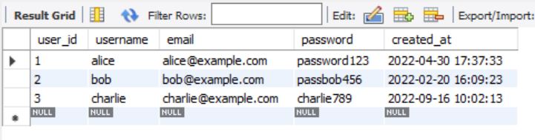

**Q2.** **Write an SQL query to list all blogs along with the corresponding user names who posted them. Assume there is a blogs table and a user’s table with a foreign key relationship**

|  |
| --- |
| SELECT b.title, u.username, b.created_at FROM blogs b  INNER JOIN users u ON b.user_id = u. user_id; |

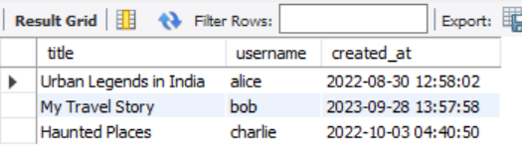

**Q3.** **Write an SQL query to list all users and their blogs, if any. Include users even if they have not written any blogs.**

|  |
| --- |
| SELECT u.username, b.title AS blog_title FROM users u  LEFT JOIN blogs b ON u. user_id = b.user_id; |

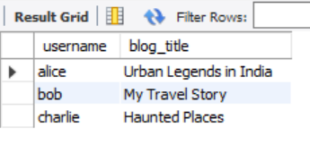

**Q4.** **Write an SQL query to retrieve the names of users who liked blogs, along with the titles of the blogs they liked.**

|  |
| --- |
| SELECT u.username, b.title AS blog_title FROM likes l  RIGHT JOIN blogs b ON l.blog_id = b. blog_id  RIGHT JOIN users u ON l.user_id = u. user_id; |

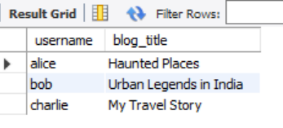

**Q5. Write an SQL query to retrieve the names of users who have commented on a specific blog, identified by its title.**

|  |
| --- |
| SELECT username FROM users  WHERE user_id IN (  SELECT user_id FROM comments  WHERE blog_id = (SELECT blog_id FROM blogs WHERE title = 'Urban Legends in India')  ); |

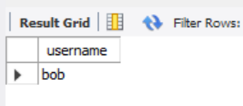

**Q6.** **Write an SQL query to show the popularity of each blog based on the number of likes it has received. Include the blog title and the total number of likes.**

|  |
| --- |
| SELECT b.title, COUNT(l. like_id) AS like_count, CASE  WHEN COUNT(l. like_id) >= 2 THEN 'Popular'  WHEN COUNT(l. like_id) = 1 THEN 'Moderate'  ELSE 'Unnoticed'  END AS popularity_status  FROM blogs b  LEFT JOIN likes l ON b.id = l.blog_id  GROUP BY b. blog_id; |

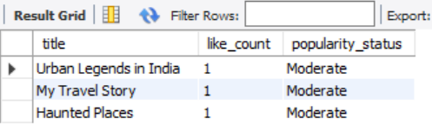

**Q7. Write an SQL statement to create a view that displays all comments along with the corresponding blog titles and the usernames of the commenters.**

|  |
| --- |
| CREATE VIEW comment_details AS  SELECT c.comment, c.commented_at, u.username, b.title AS blog_title  FROM comments c  JOIN users u ON c.user_id = u user_id  JOIN blogs b ON c.blog_id = b.blog_id; |

|  |
| --- |
| SELECT * FROM comment_details; |

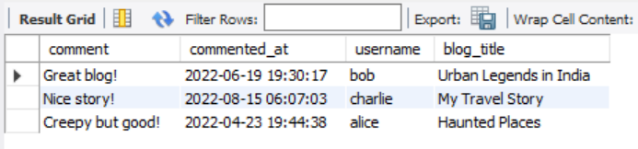

**Q8.** **Write a stored procedure to insert a new story into the stories table. The procedure should accept parameters such as title, content, user ID, and date.**

|  |
| --- |
| DELIMITER $  CREATE PROCEDURE AddStory (  IN p_user_id INT,  IN p_title VARCHAR(255),  IN p_content TEXT,  IN p_image_url VARCHAR(255)  )  BEGIN  INSERT INTO stories (user_id, title, content, image_url, created_at)  VALUES (p_user_id, p_title, p_content, p_image_url, NOW());  END $  DELIMITER ; |

|  |
| --- |
| CALL AddStory(1, 'Lost Town', 'A town vanished overnight...', 'losttown.jpg'); |

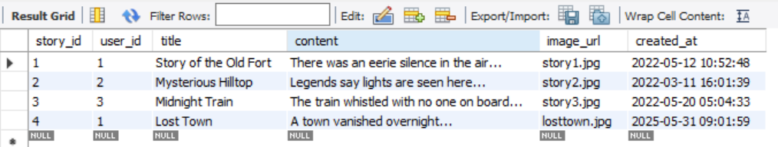

**Q9.** **Write a cursor in SQL to iterate through all users who have posted blogs and display their usernames one by one. Simulate the logic using appropriate cursor declarations and control flow.**

|  |
| --- |
| DELIMITER $  CREATE PROCEDURE ShowBloggers()  BEGIN  DECLARE done INT DEFAULT FALSE;  DECLARE v_name VARCHAR(255);  DECLARE cur CURSOR FOR  SELECT DISTINCT u.username  FROM users u  JOIN blogs b ON u.user_id = b.user_id;  DECLARE CONTINUE HANDLER FOR NOT FOUND SET done = TRUE;  OPEN cur;  read_loop: LOOP  FETCH cur INTO v_name;  IF done THEN  LEAVE read_loop;  END IF;  SELECT v_name AS blogger;  END LOOP;  CLOSE cur;  END $  DELIMITER ; |

|  |
| --- |
| CALL ShowBloggers(); |

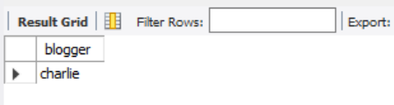

**Q10.** **Write a trigger that logs an entry whenever a new comment is added to the comments table. The log should record details such as the comment ID, user ID, blog ID, and timestamp.**

|  |
| --- |
| CREATE TABLE comment_log (  log_id INT AUTO_INCREMENT PRIMARY KEY,  comment_text TEXT,  log_time DATETIME  );  DELIMITER $  CREATE TRIGGER after_comment_insert  AFTER INSERT ON comments  FOR EACH ROW  BEGIN  INSERT INTO comment_log (comment_text, log_time)  VALUES (NEW.comment, NOW());  END $  DELIMITER ; |

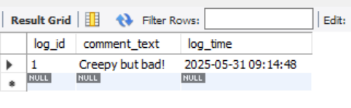

**Q.11. Write an SQL query using aggregate functions and GROUP BY to show the total number of blogs and stories posted by each user.**

|  |
| --- |
| SELECT u.username,  COUNT(DISTINCT b.blog_id) AS total_blogs,  COUNT(DISTINCT s.story_id) AS total_stories  FROM users u  LEFT JOIN blogs b ON u.user_id = b.user_id  LEFT JOIN stories s ON u.user_id = s.user_id  GROUP BY u.user_id; |

